Theme ( Dark Mode )

1st to make whole background black,

App.css

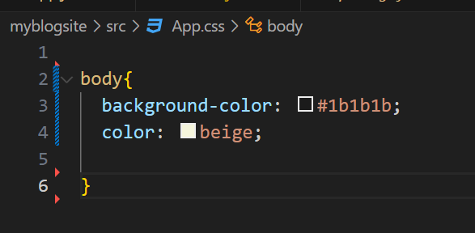

O/P

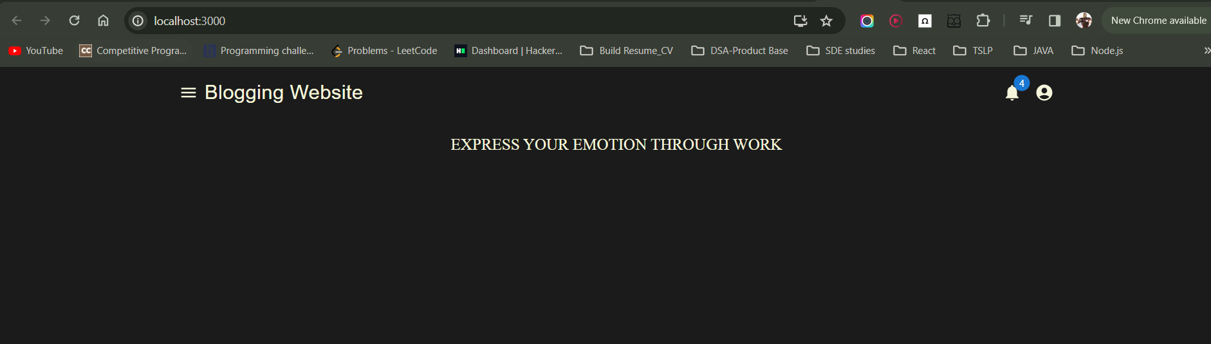

================Dark Theme=============

Go to MIUI

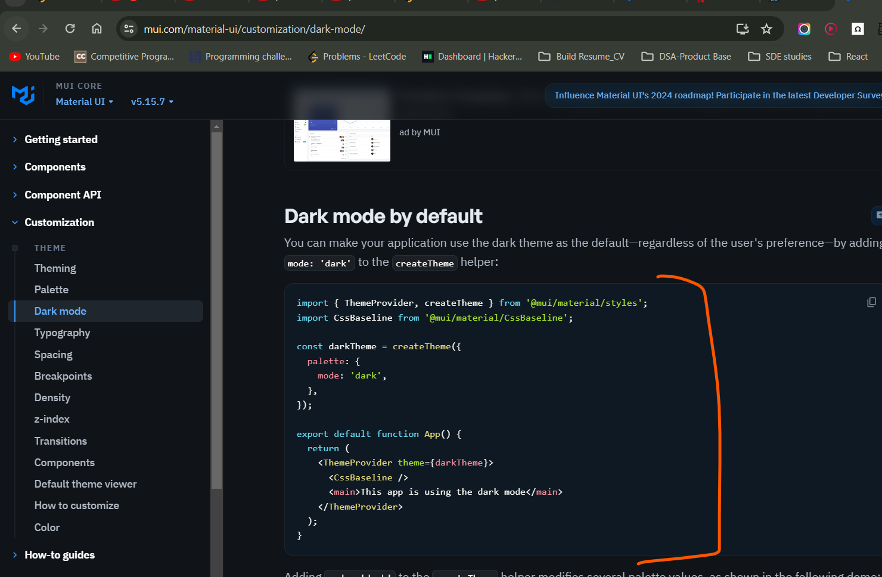

Go to app.js

Step 1

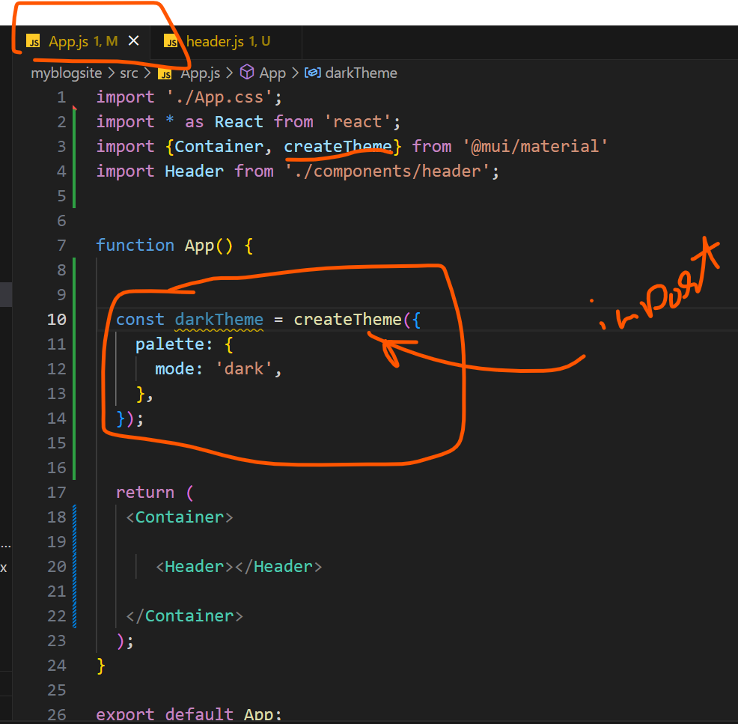

Step 2

